Chapter 10, Solution 6.

Determine V_{x} shown in Fig. 10.55

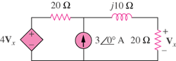

Figure 10.55
For Prob. 10.6.

Solution

Let V_{o} be the voltage across the current source. Using nodal analysis, we get:

where

Combining these we get:

29.11∠–166˚ V.

